ACCESS AUDIT
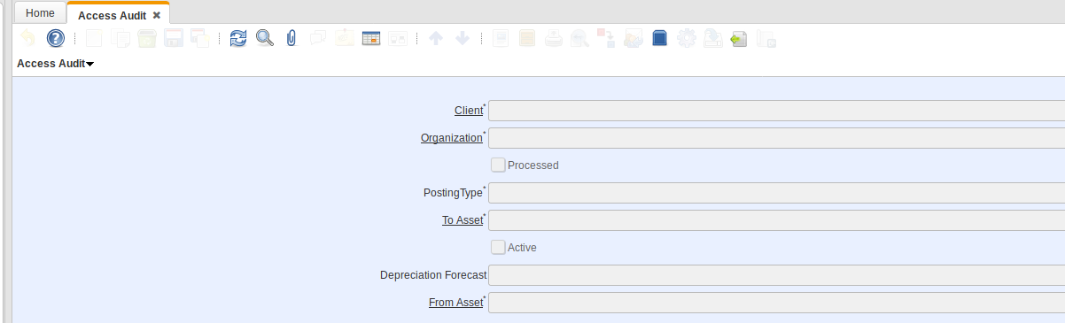

ADVERTISEMENT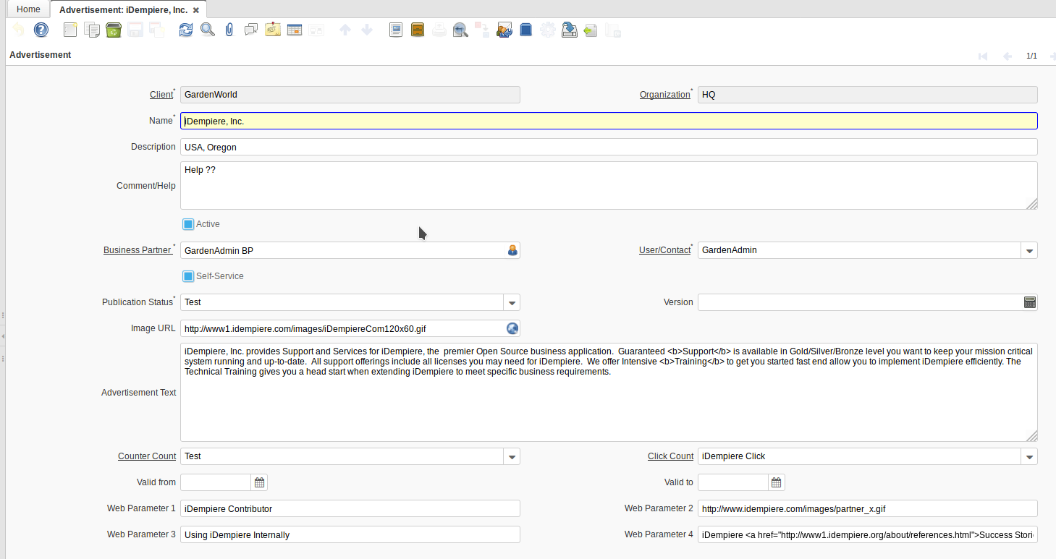ASSET CLASS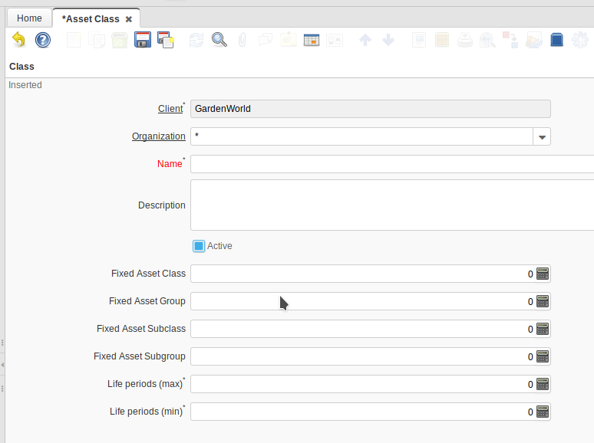

ASSET DISPOSAL2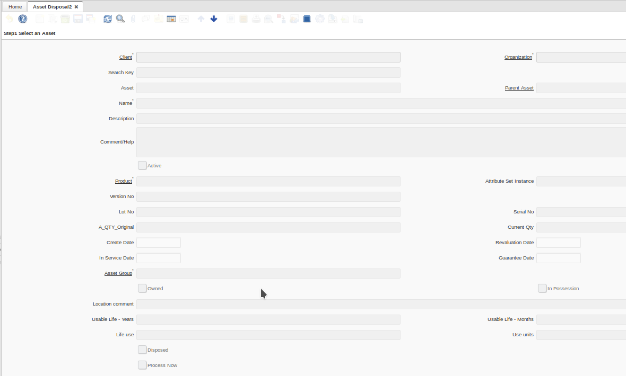

ASSET TYPE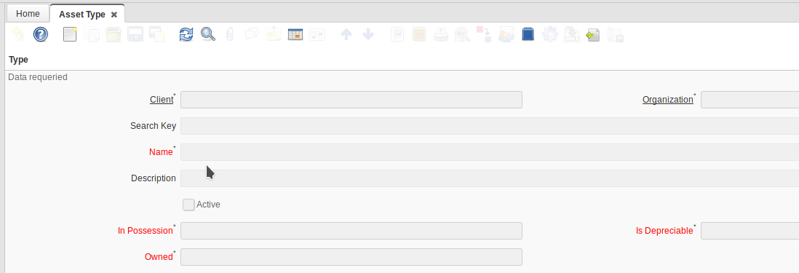

ATTRIBUTE SEARCH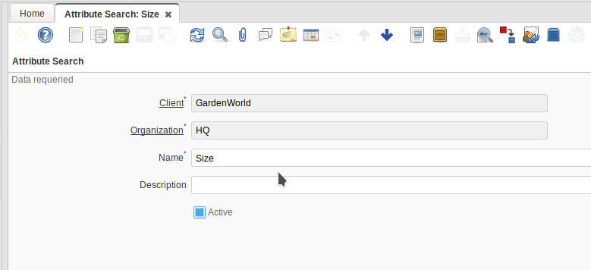

AUCTION BUYER 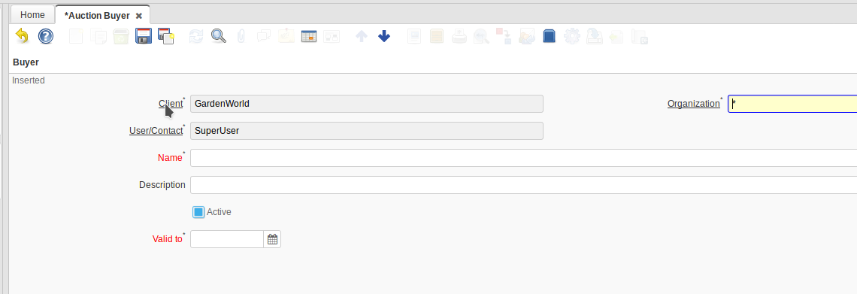

AUCTION SELLER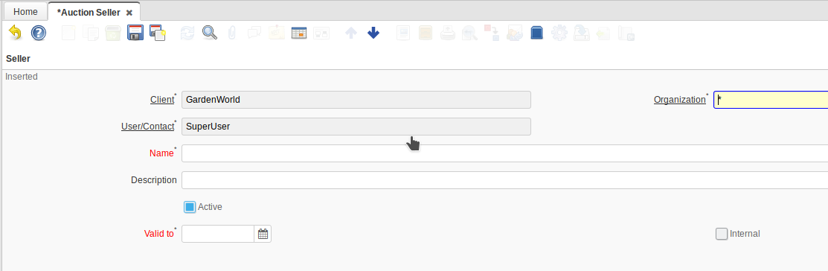

Auction Topic Type
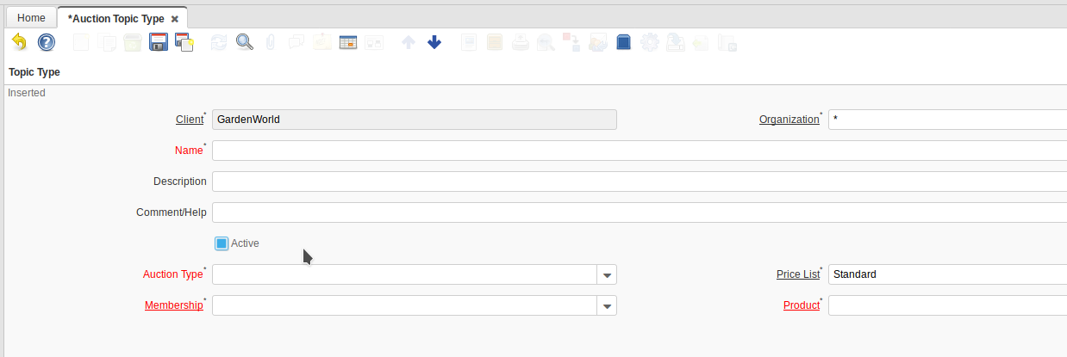

Bid Topic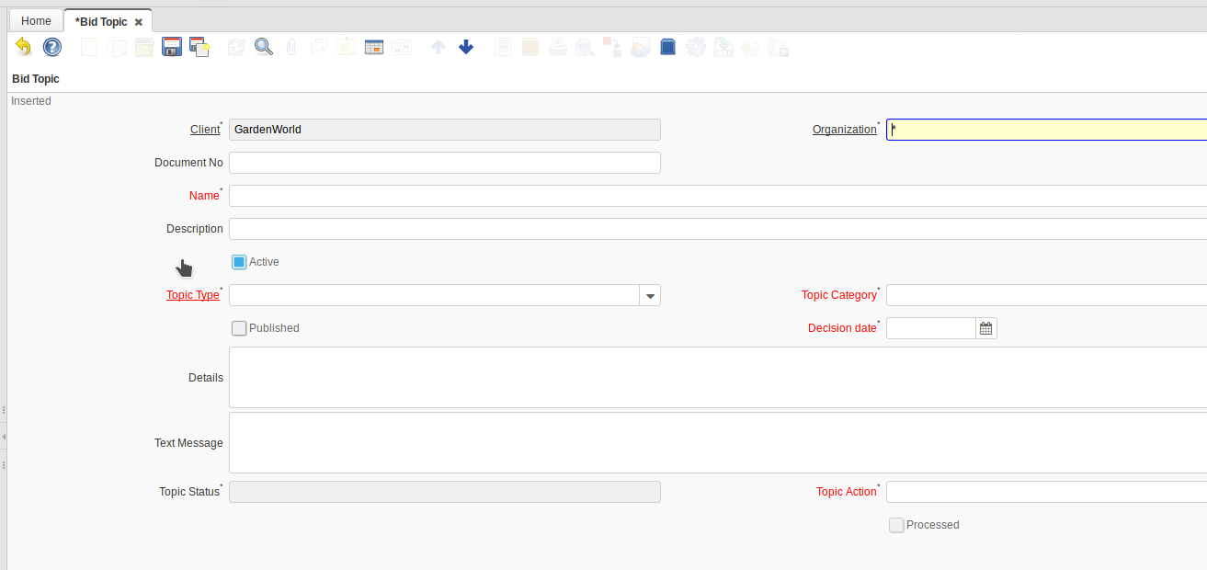

Budget Control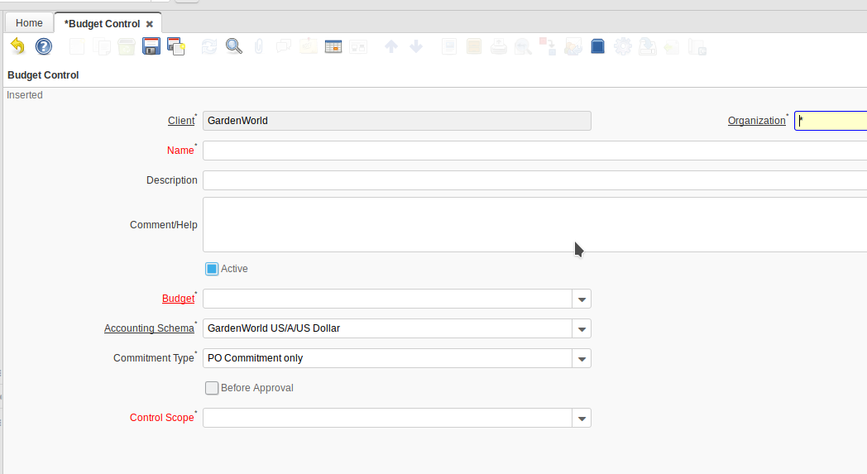

Cash Journal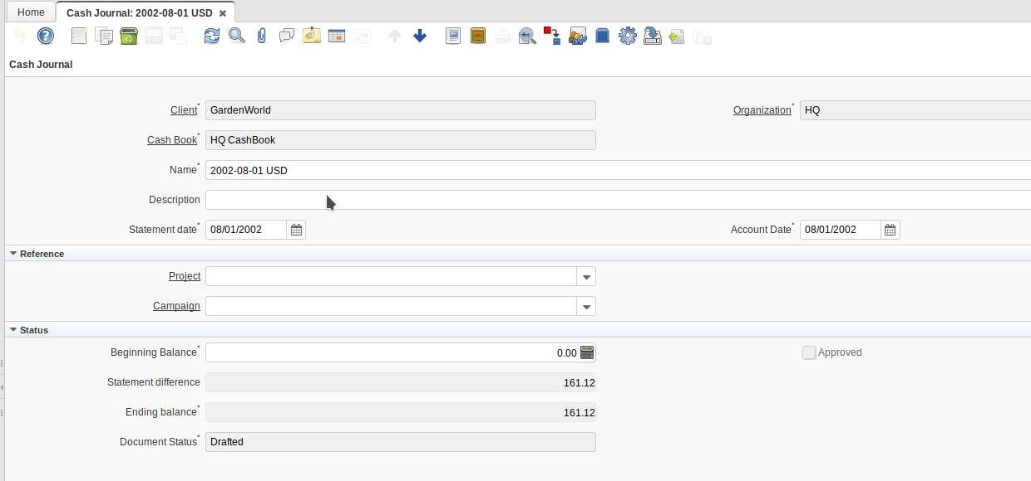

Cashbook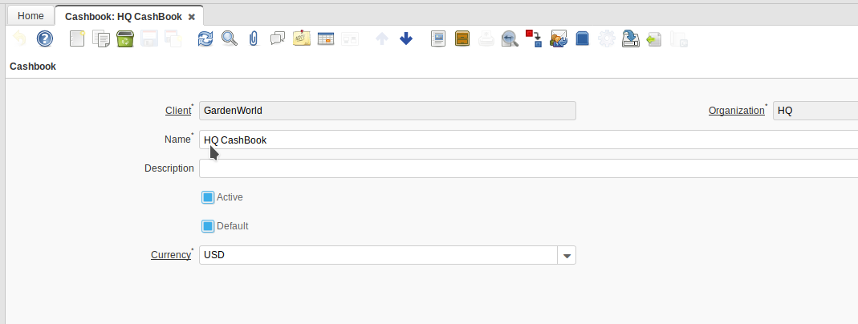

Click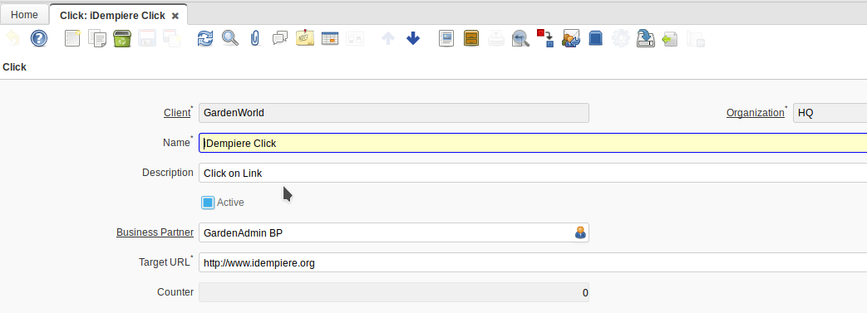

Common Package Details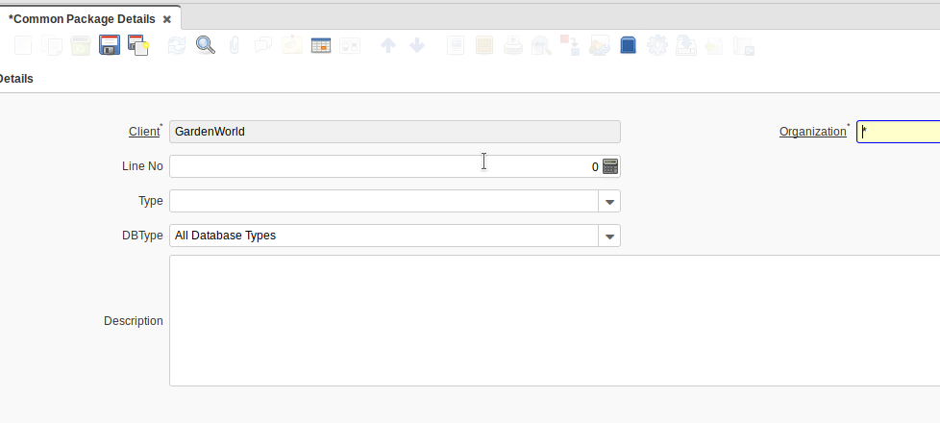

Counter
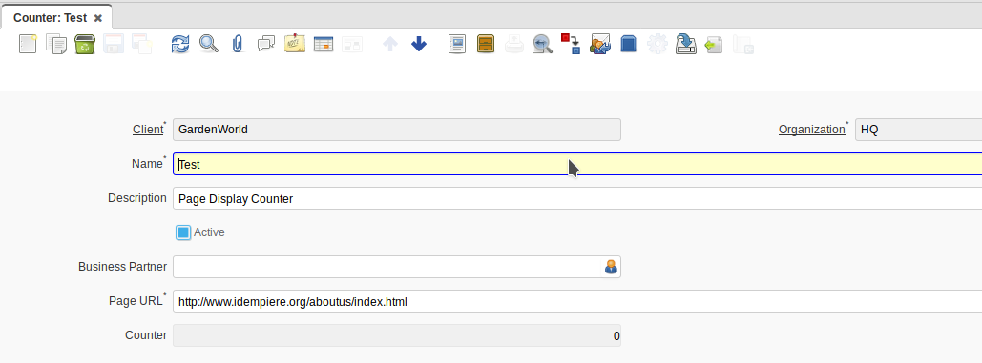

Custom Attribute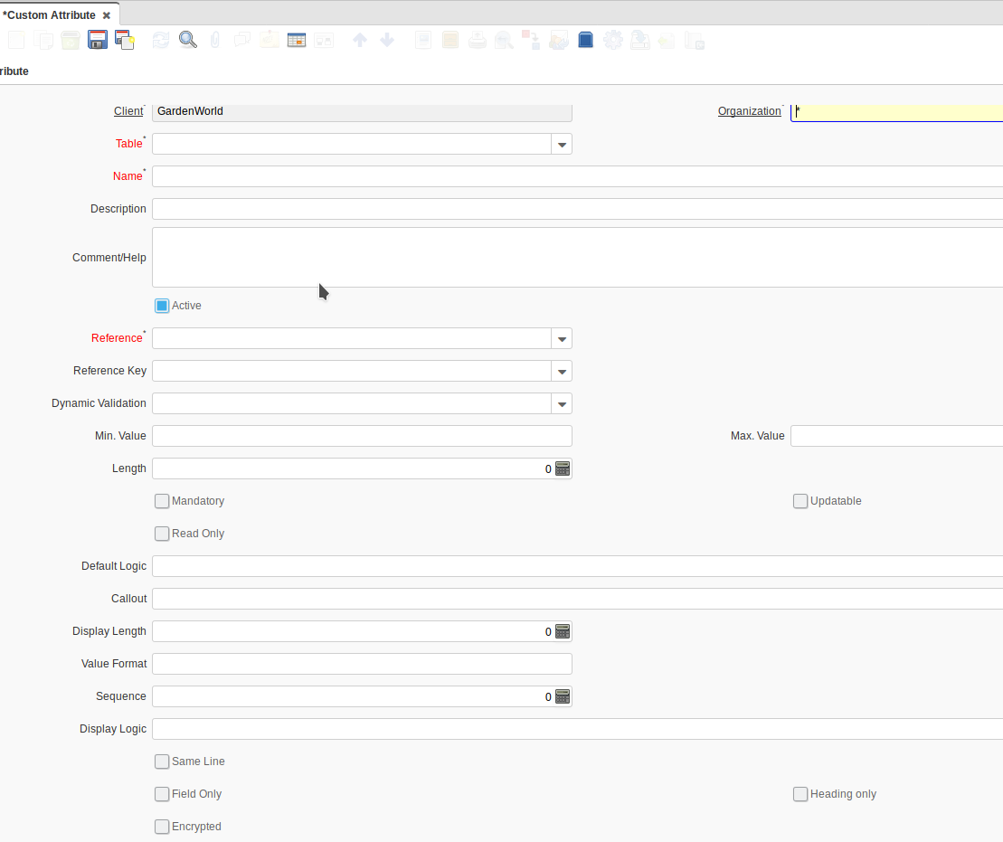

Demand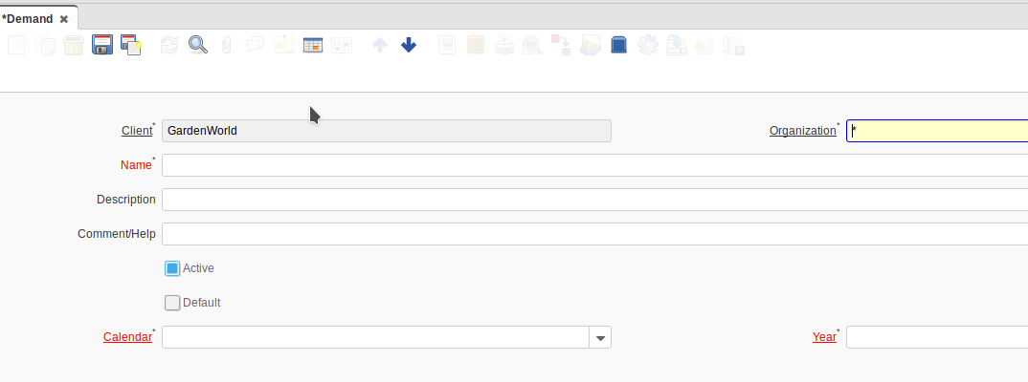

Desktop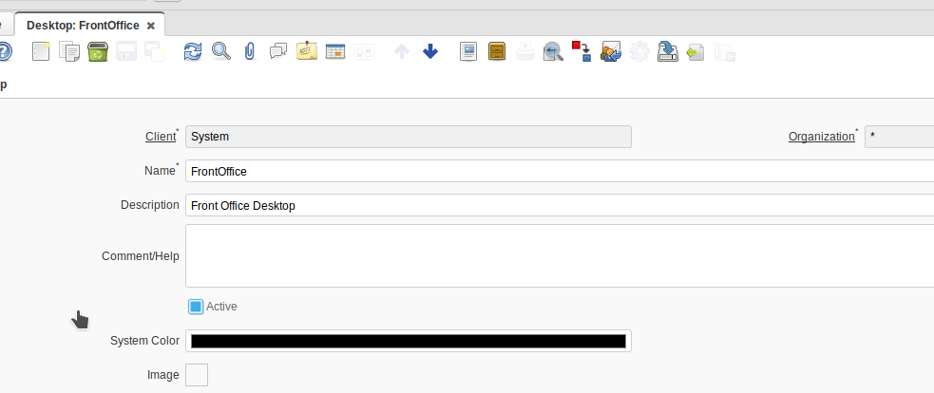

Distribution Order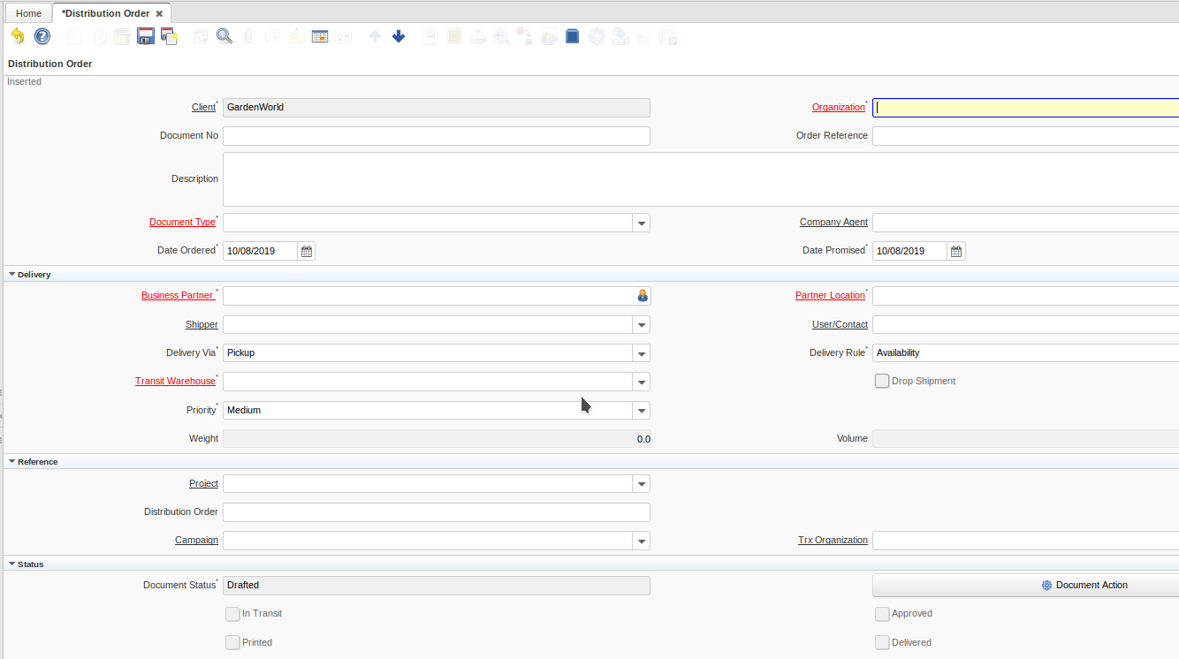

EDI Definition (C’È NEL MENÙ MA MANCA L’ACCESSO)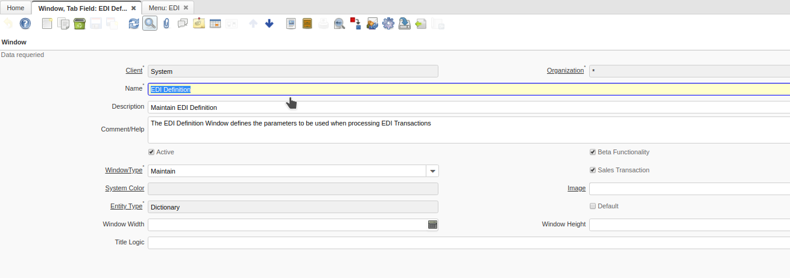

EDI Transaction (C’È NEL MENÙ MA MANCA L’ACCESSO)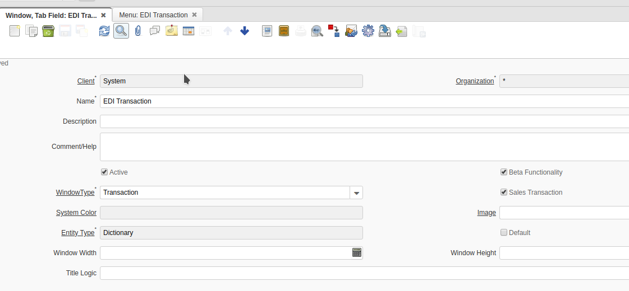
Expense Invoice (Alpha)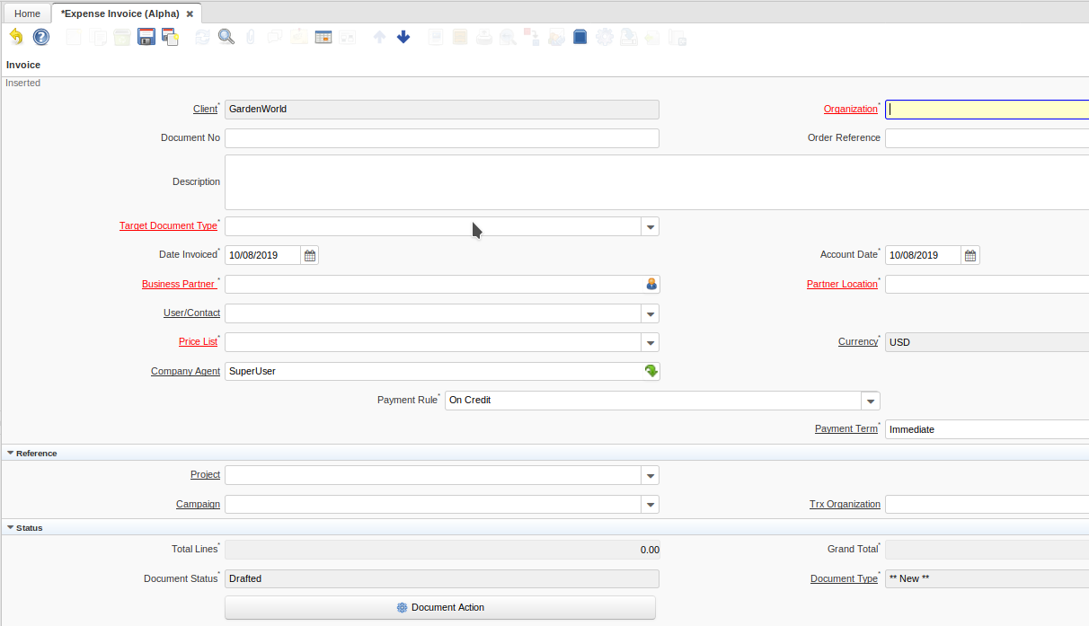
GL Fund (Alpha)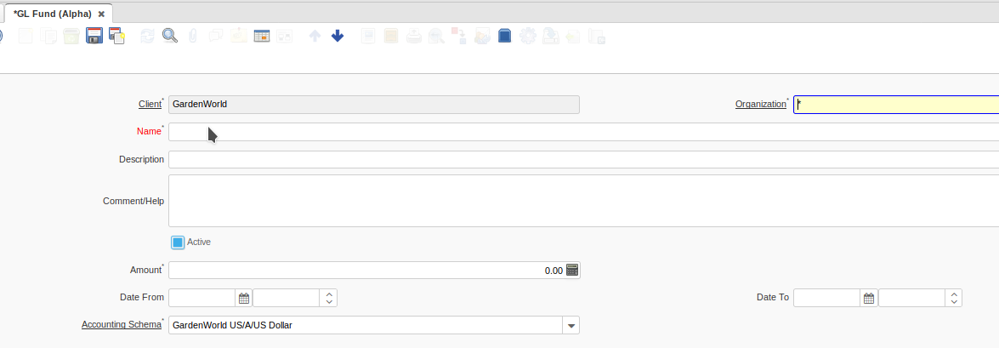

Import Payroll Movement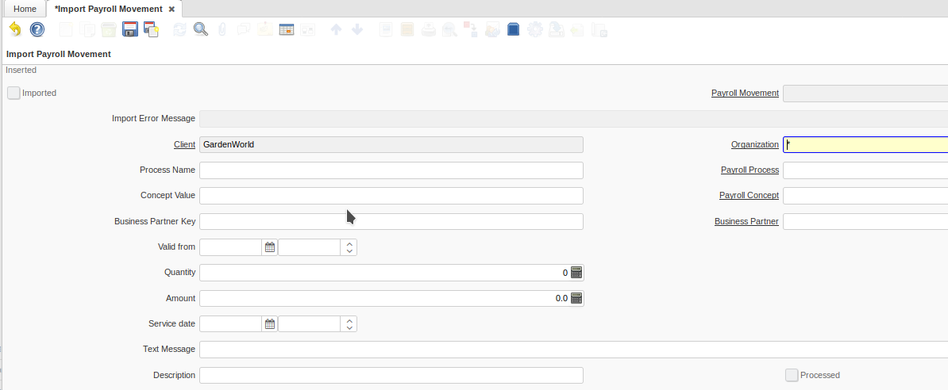

Import Product Planning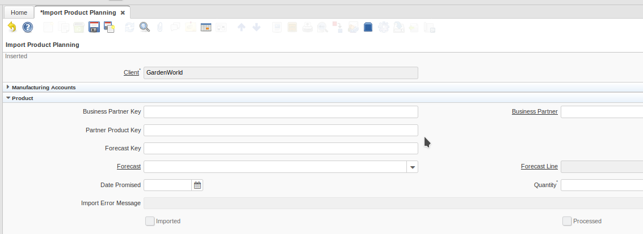

Issue Project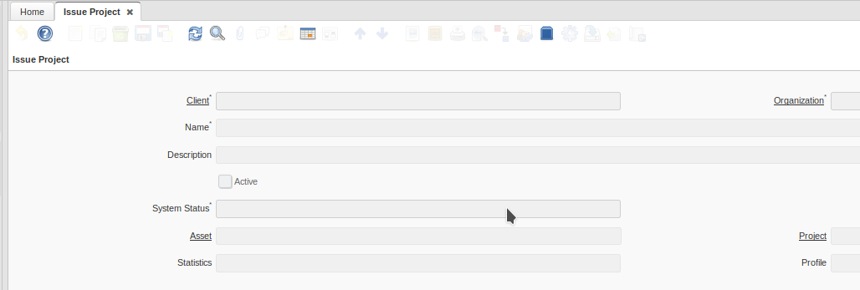

Issue Recommendation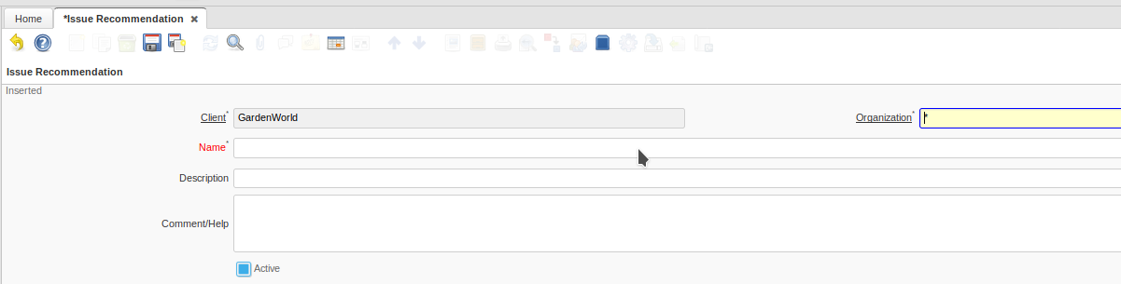

Issue Status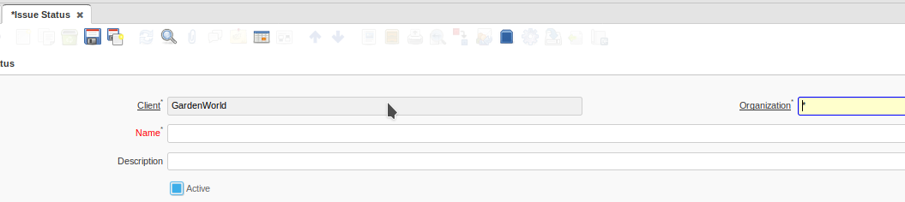

Issue System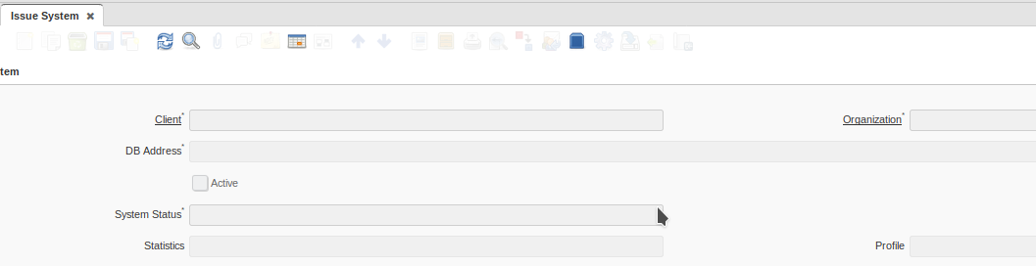
Issue User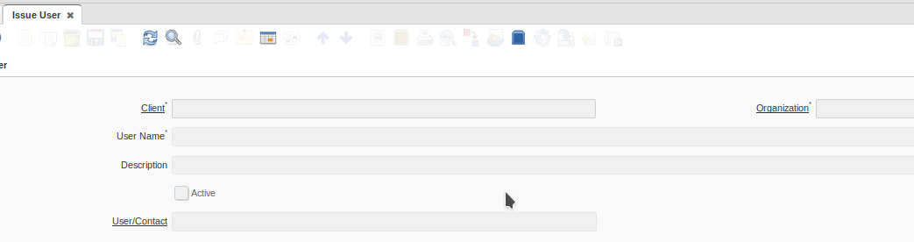

Knowledge Base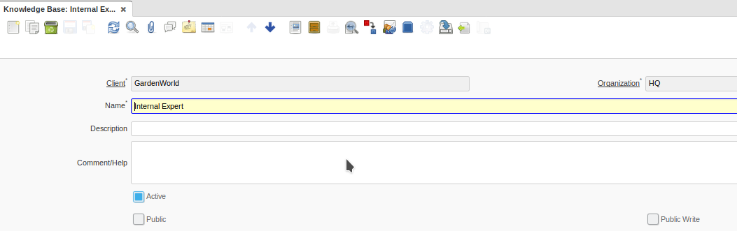

Knowledge Category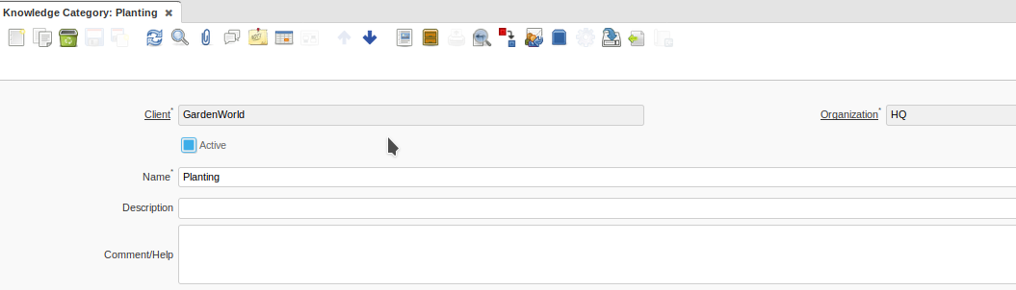

Knowledge Source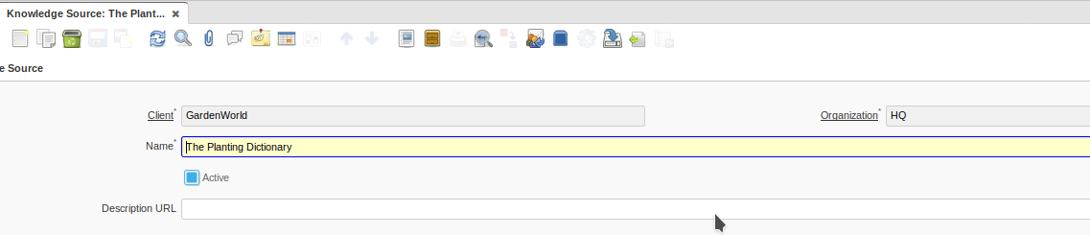

Knowledge Synonym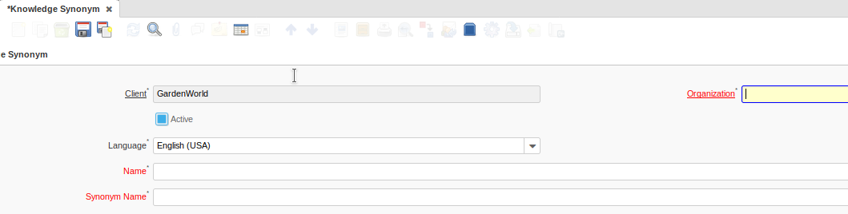

Known Issue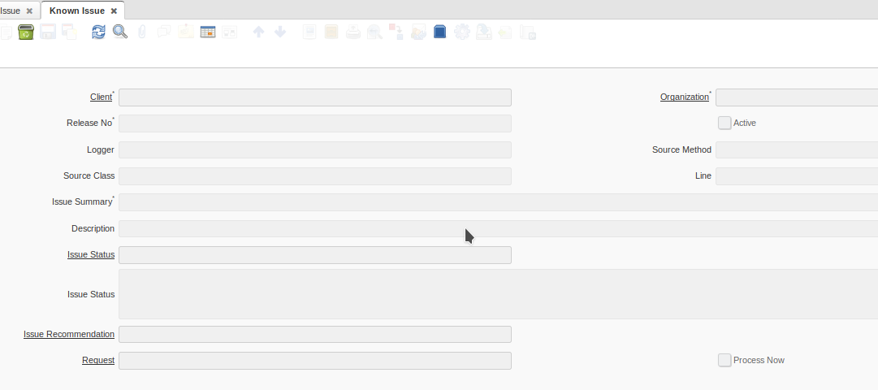

Media Item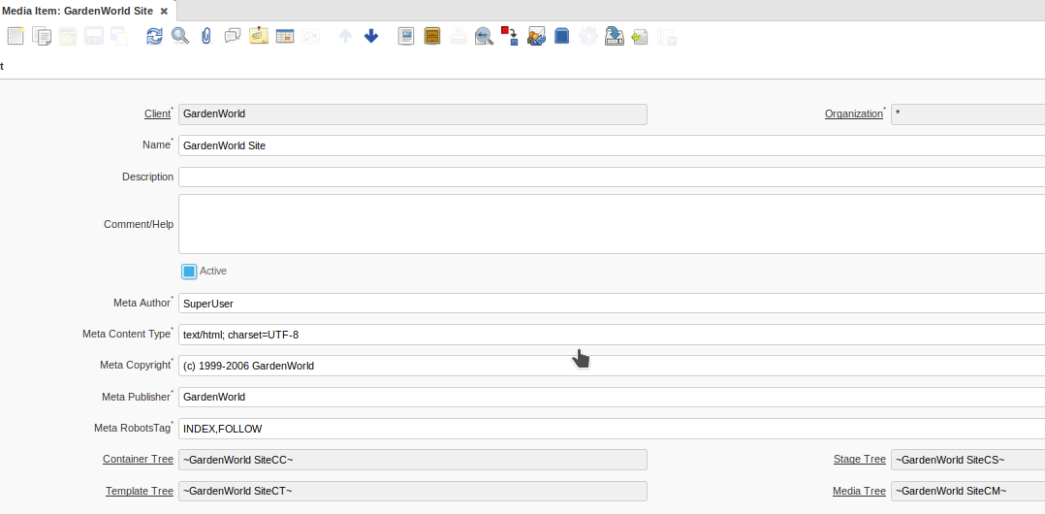

News Channel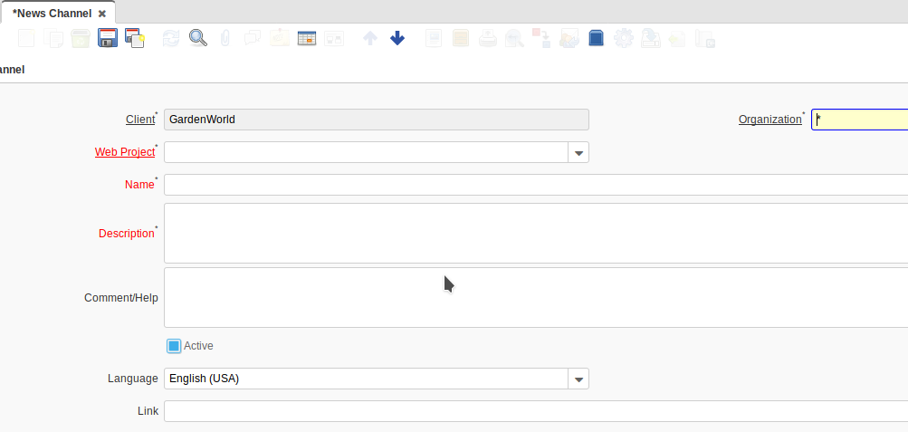

Package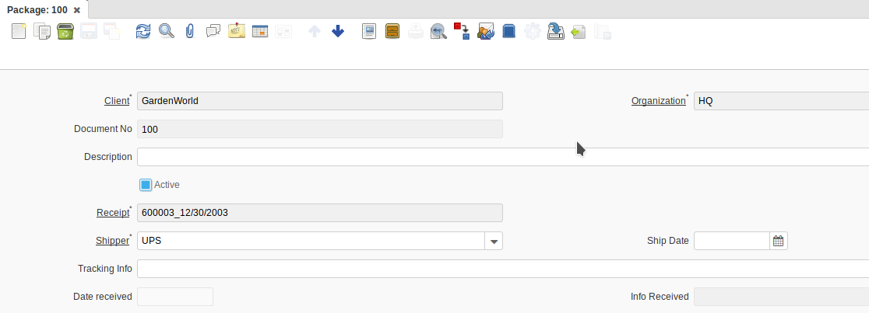

Payroll Concept Catalog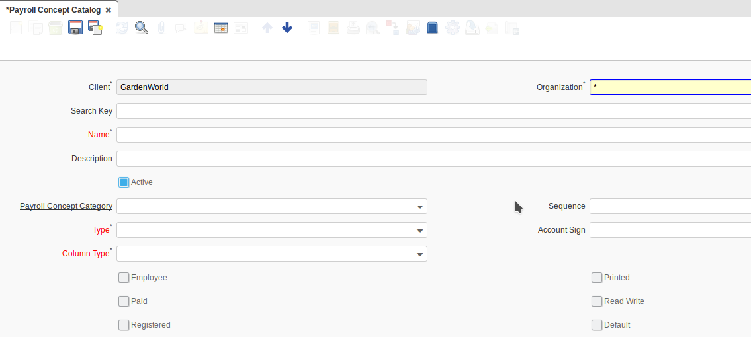

Payroll Concept Category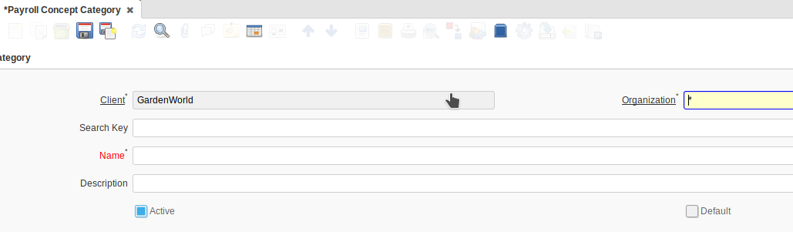

Payroll Contract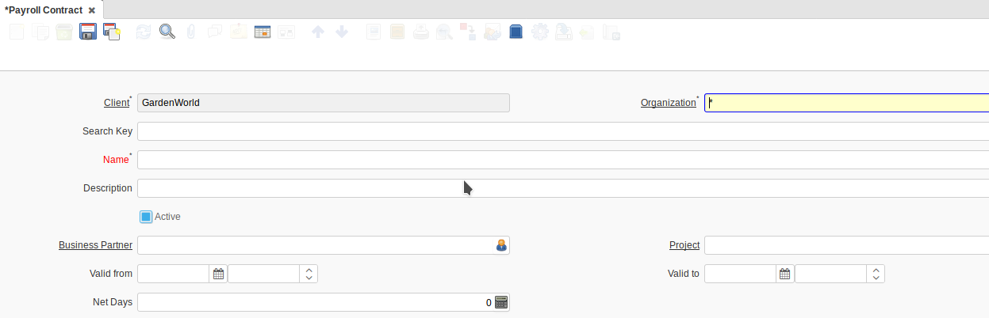

Payroll Definition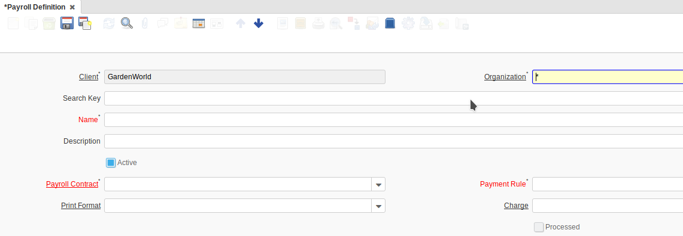

PAYROLL DEPARTMENT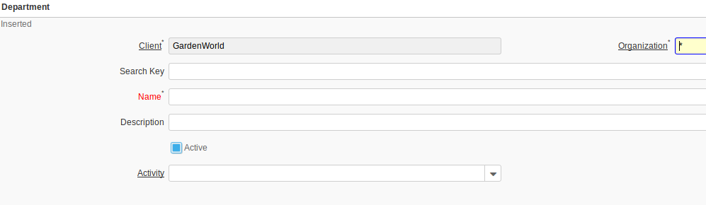
PAYROLL EMPLOYEE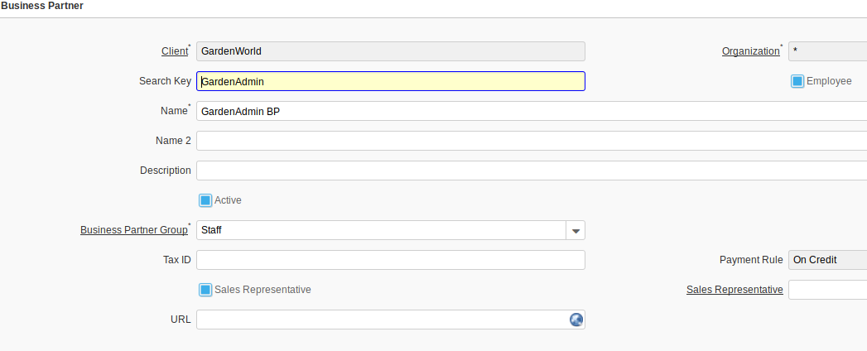
PAYROLL JOB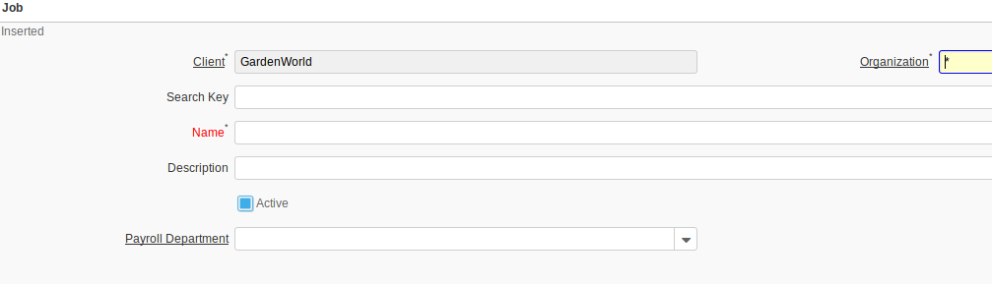
PAYROLL MOVEMENT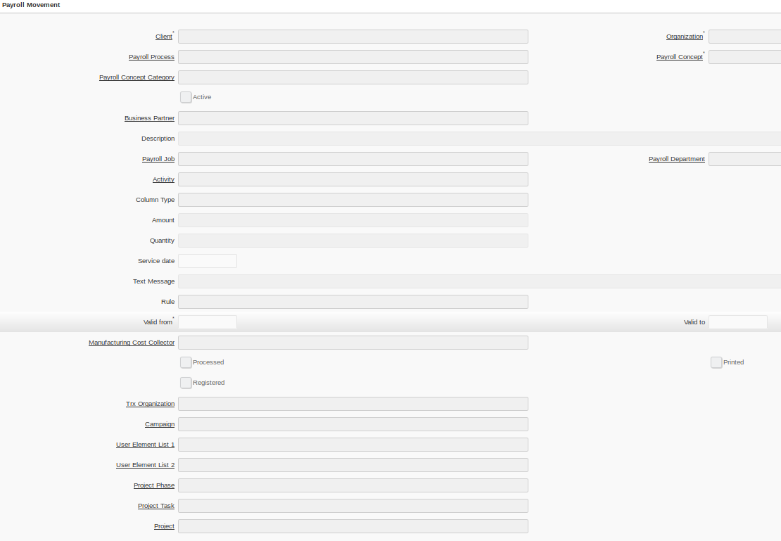
PAYROLL PROCESS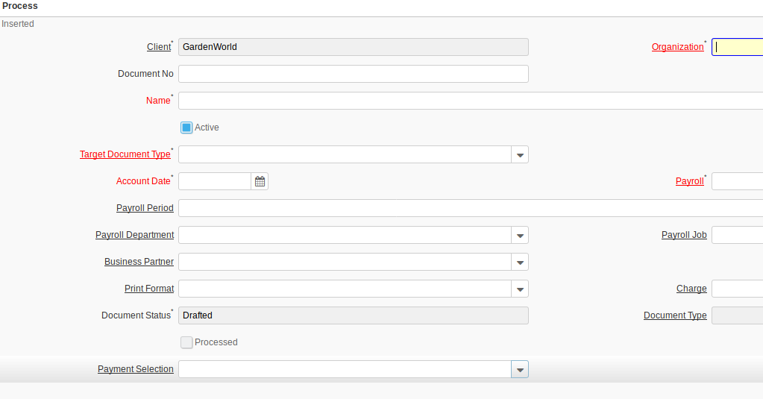
PAYROLL TABLE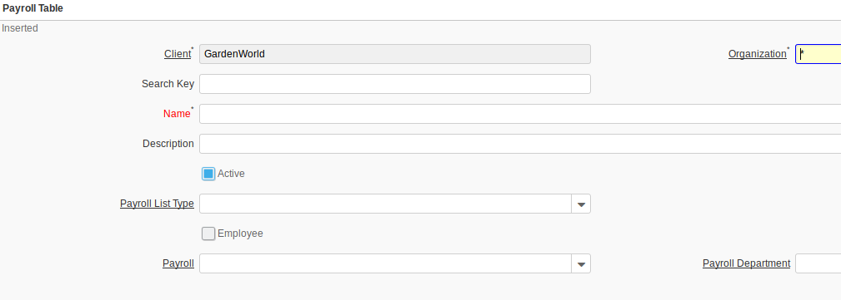
PAYROLL TABLE TYPE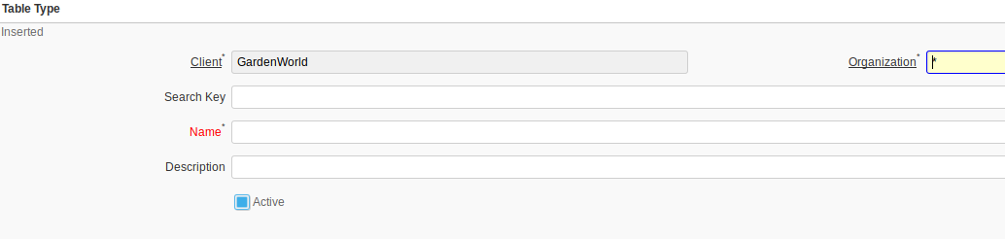
PERPETUAL INVENTORY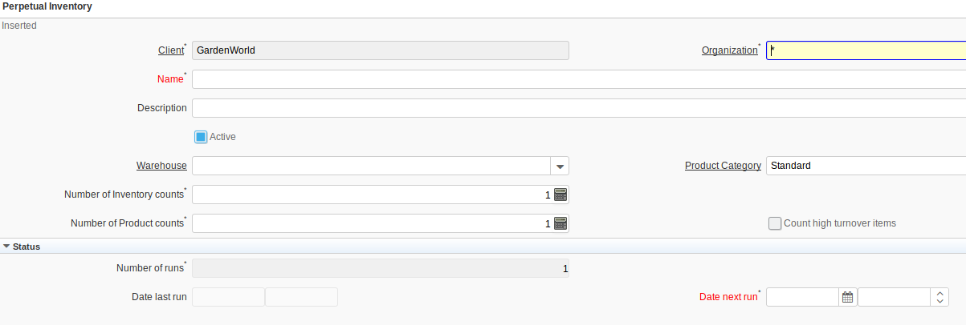
PRODUCTION BOM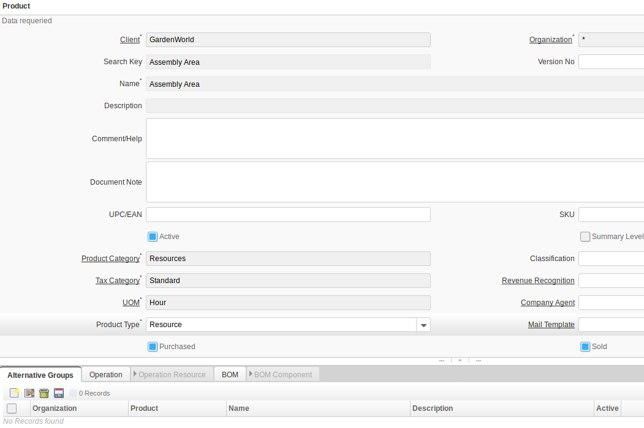
PRODUCTION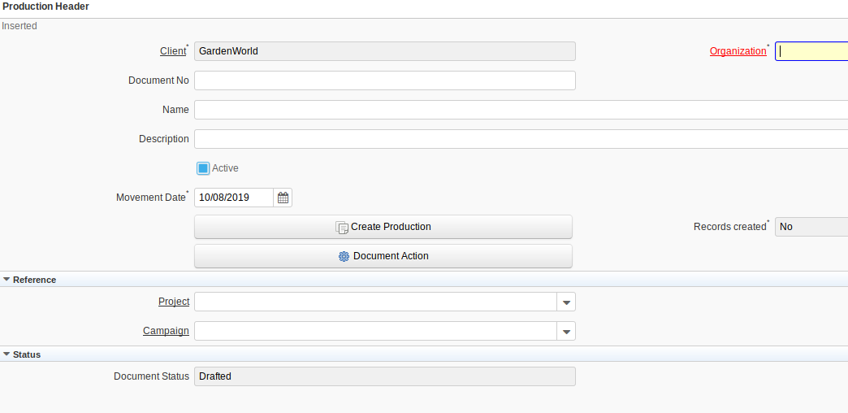
SLA CRITERIA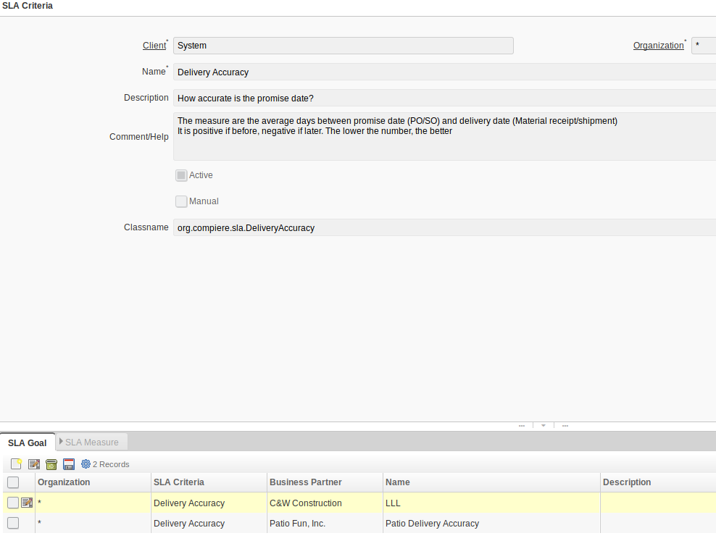
SLA BY PARTNER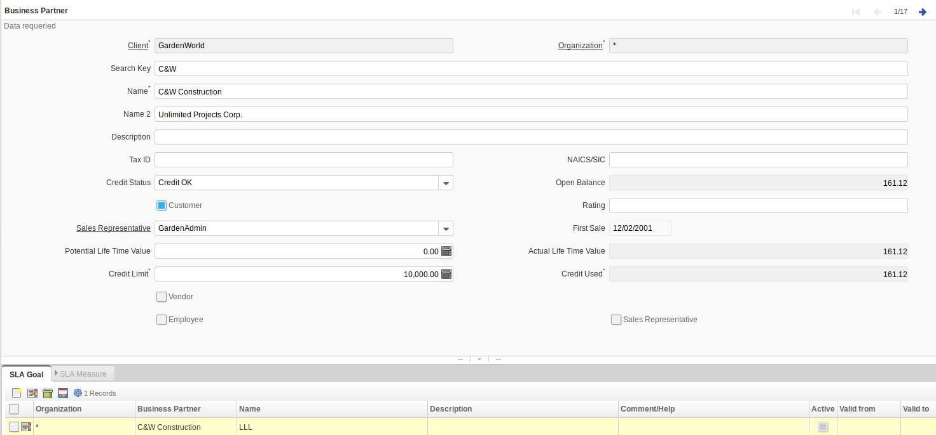
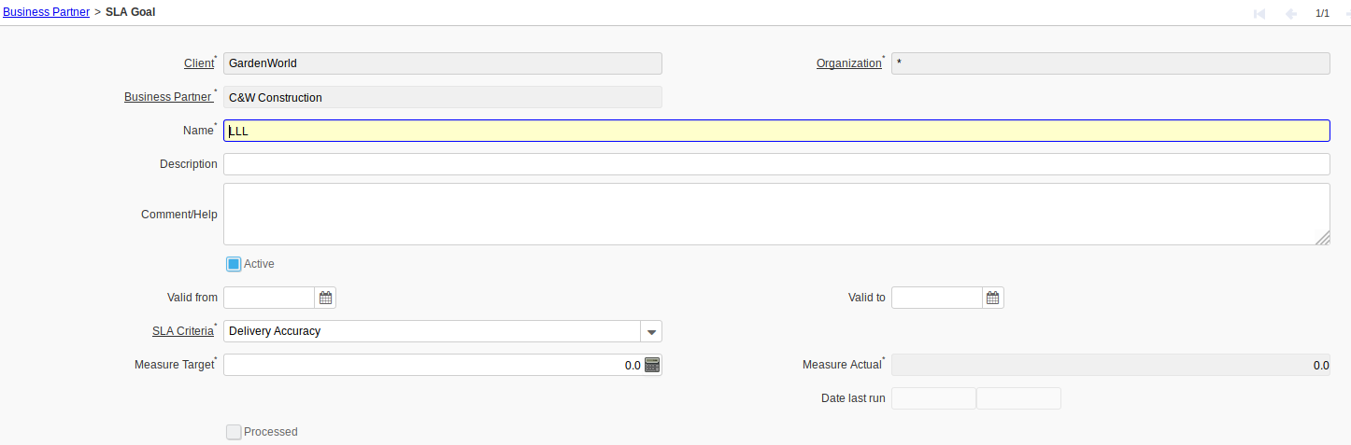
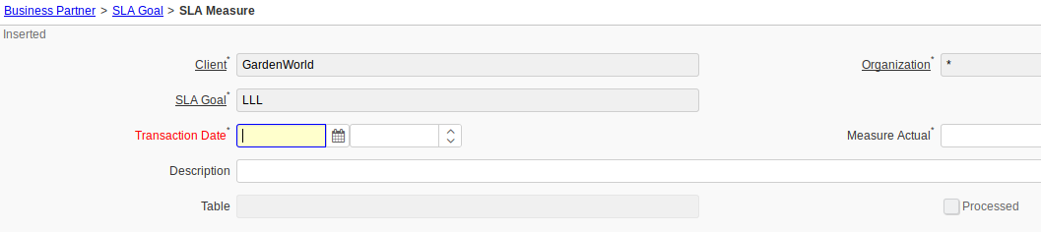
SERVICE LEVEL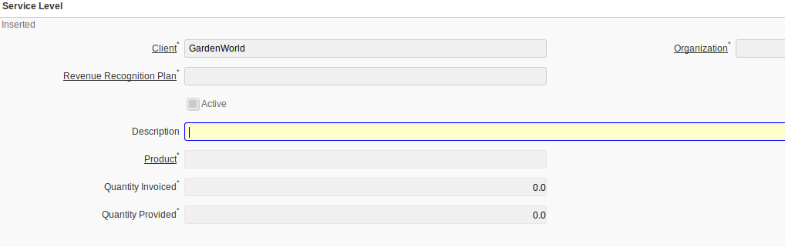
SUBSCRIPTION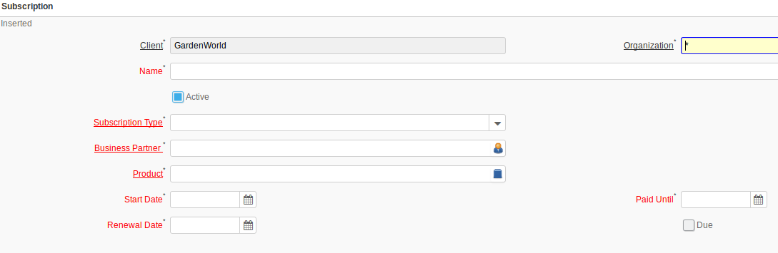
SUBSCRIPTION TYPE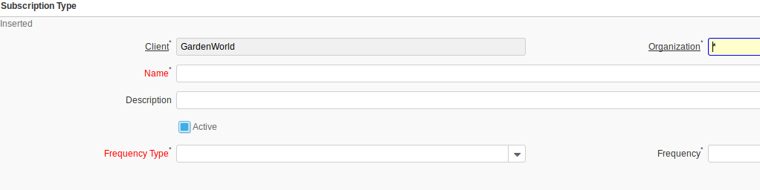
SYSTEM COLOR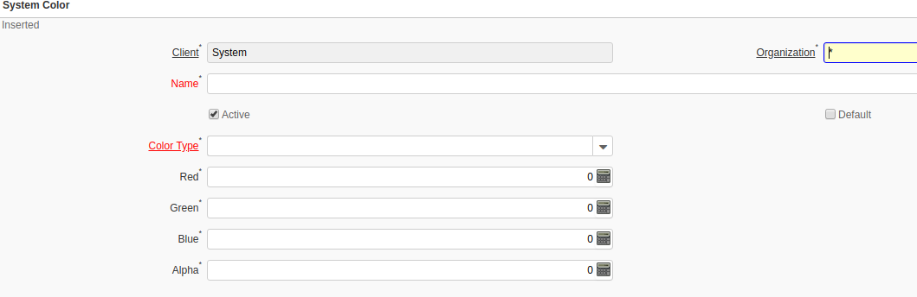
SYSTEM REGISTRATION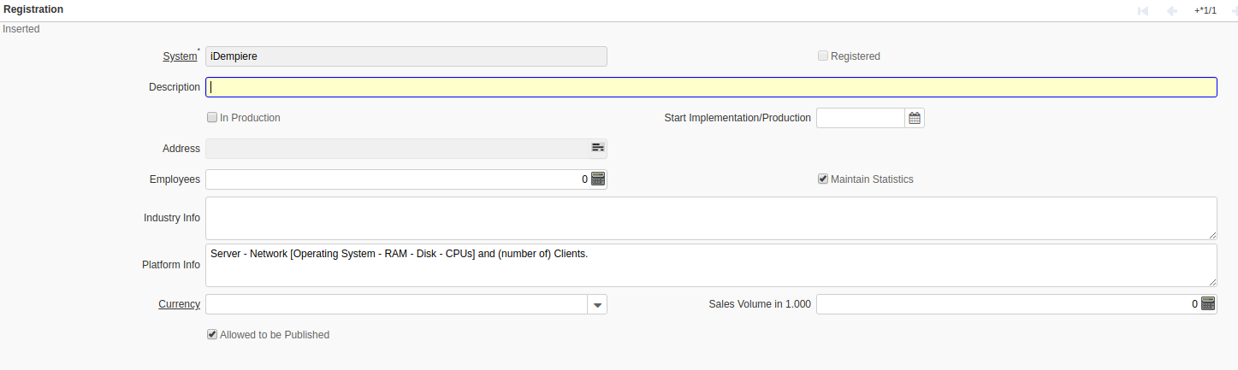
TAX BASE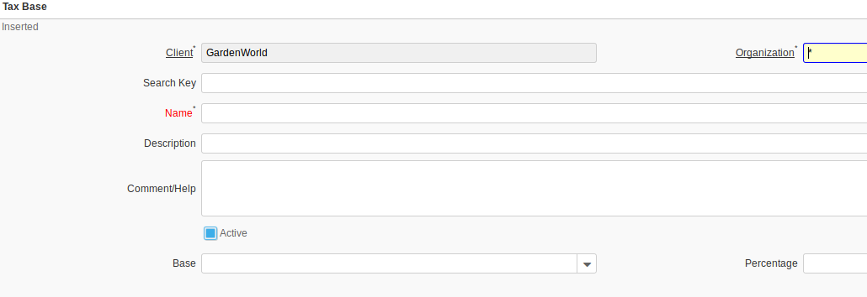
TAX DECLARATION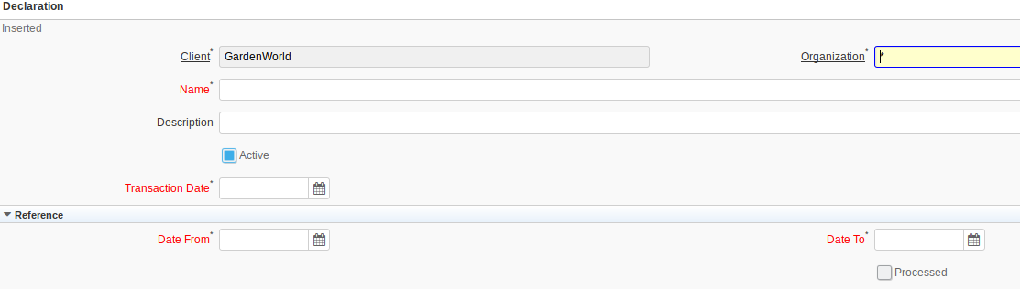
TAX DEFINITION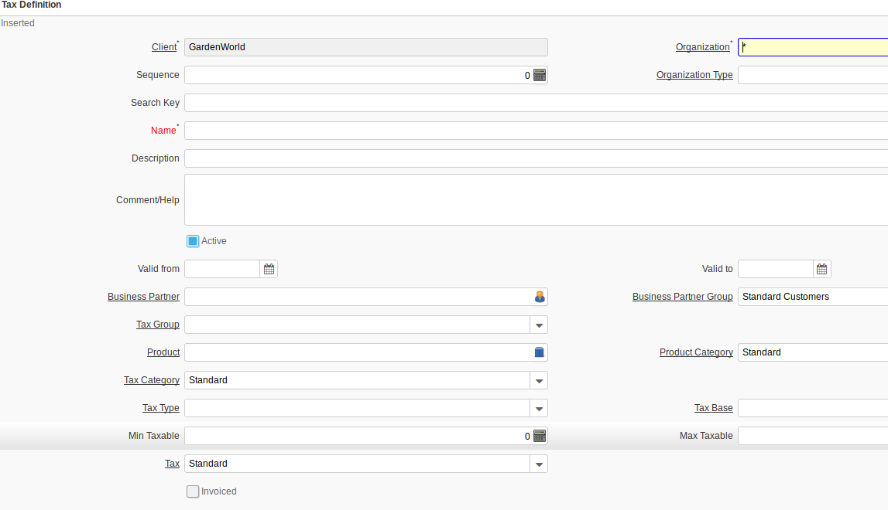
TAX GROUP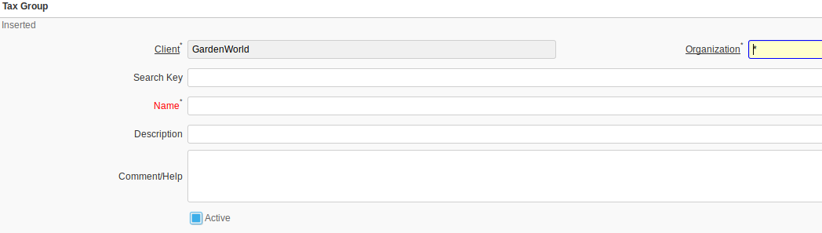
TAX RATE PARENT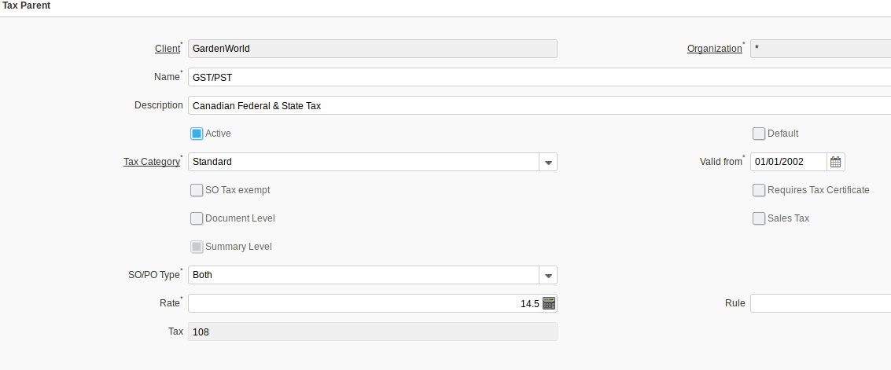
TAX TYPE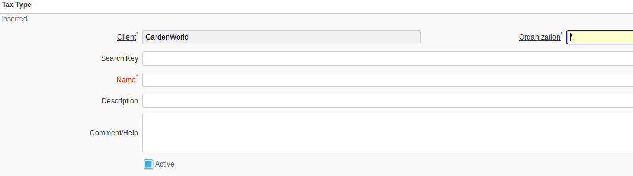

TEMPALATE (VUOTA)

TEXT INDEX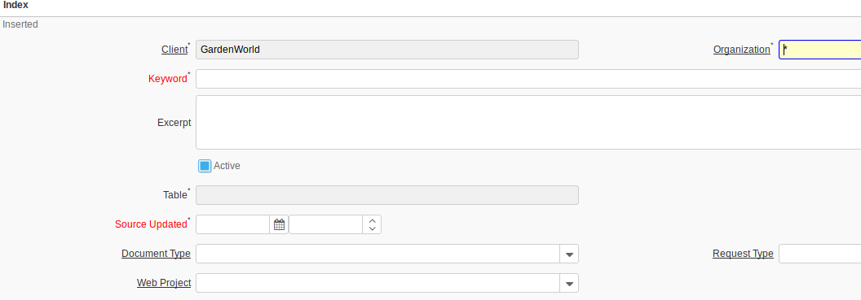
TEXT INDEX STOP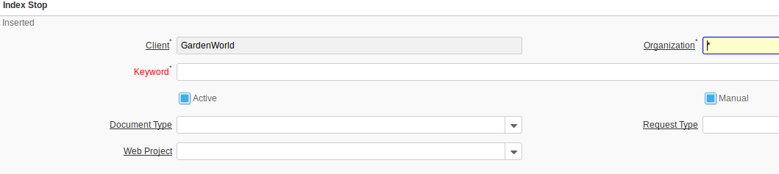
TEXT SEARCH LOG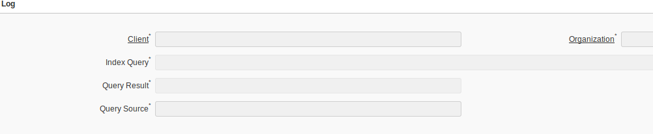
TRAINING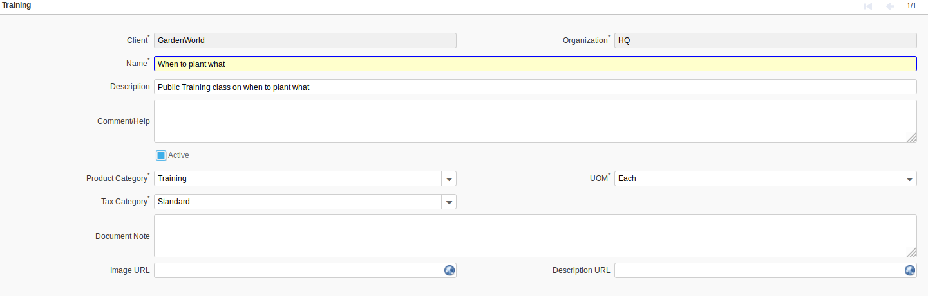
WEB ACCESS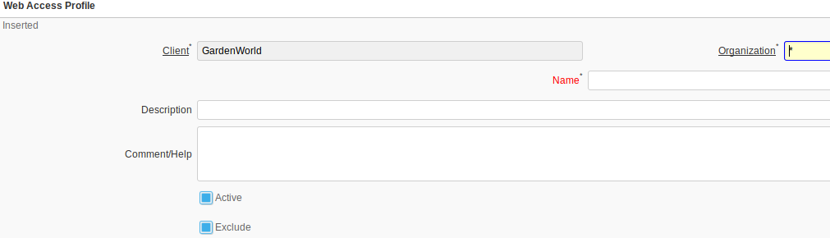
WEB AD MANAGEMENT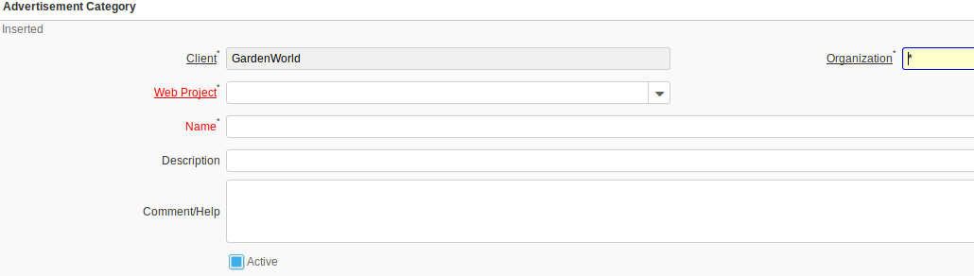
WEB BROADCAST SERVER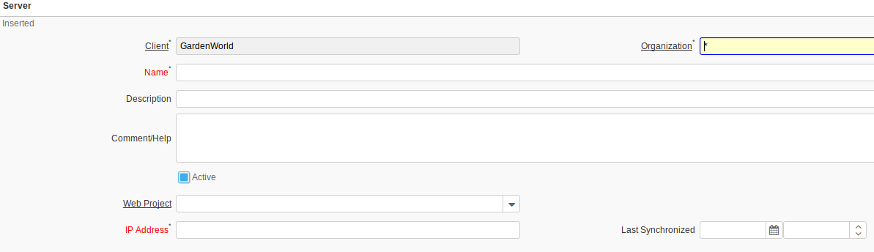
WEB POS BLACKLISTCHEQUE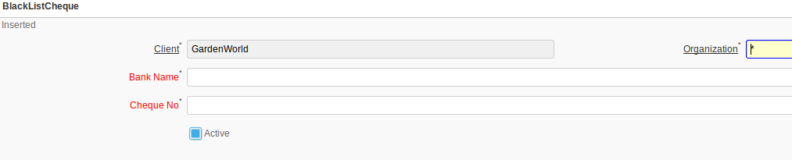
WEB POS MENU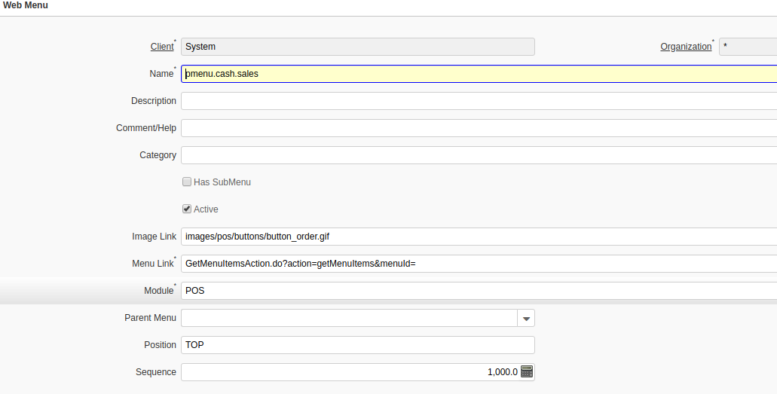
WEB POS PROPERTIES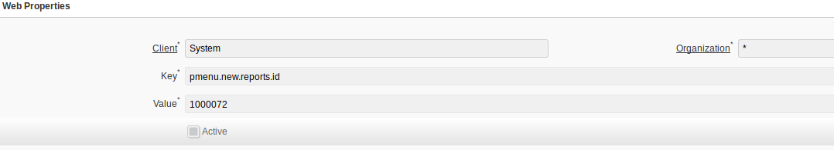
WEB POS ROLE MENU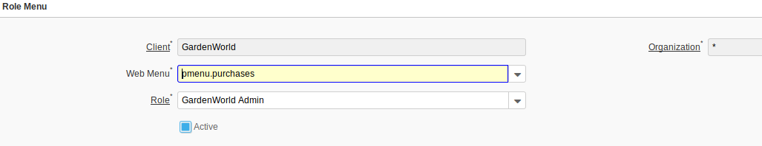
WEB POS TERMINAL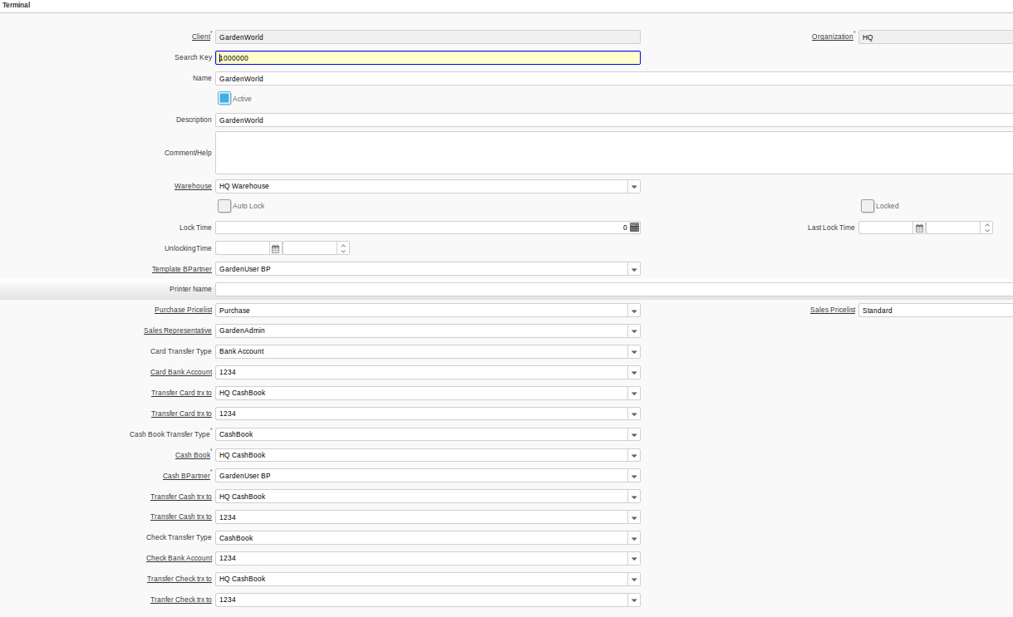
WEB PROJECT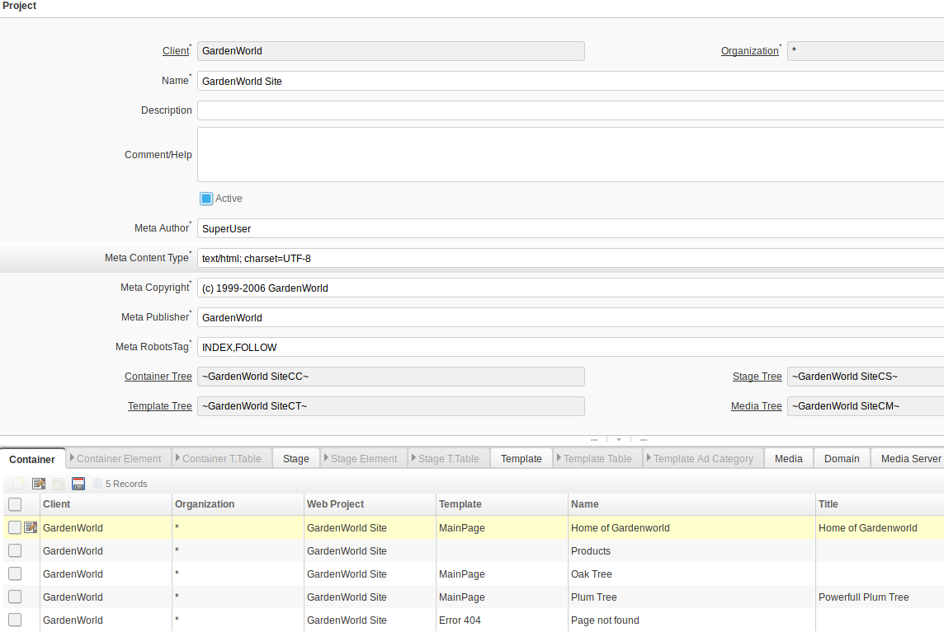
WITHHOLDING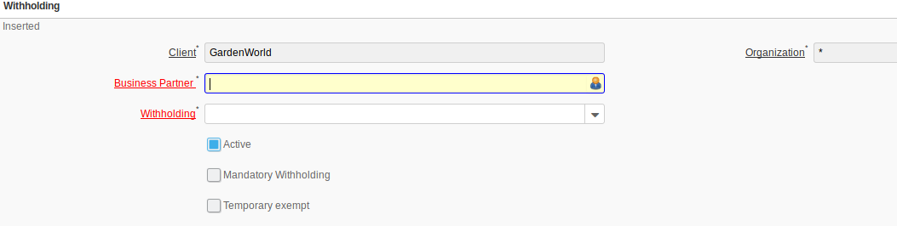
WITHHODLING (1099)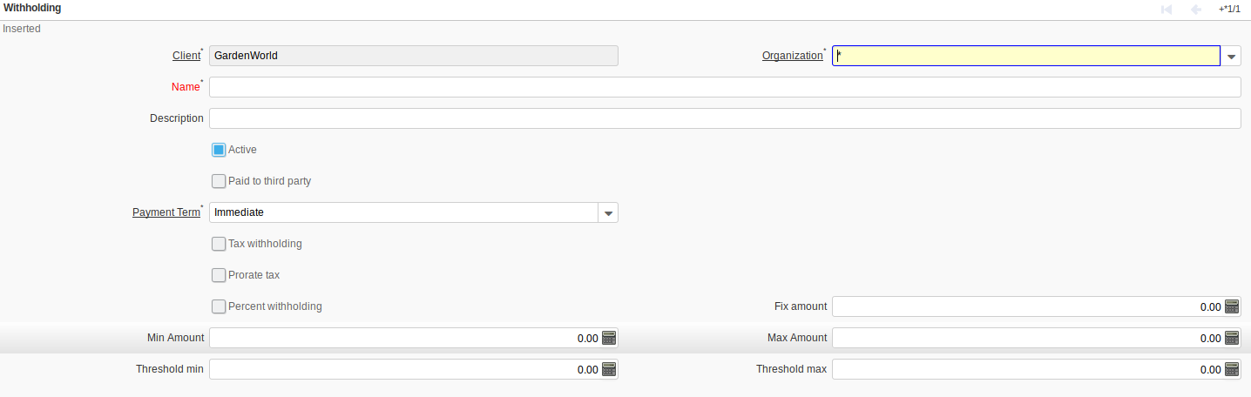
WORKBENCH

